

Technological University of the Philippines
COLLEGE OF LIBERAL ARTS
SOCIAL SCIENCE DEPARTMENT

BETMT-AET-1A-M
UNDERSTANDING THE SELF
ACTIVITY # 4

My Self Through the Years

Attached a picture of you when you were in elementary, in high school, and now that you are in college. Below the picture, list down your salient characteristics that you remember.

- My Elementary Self
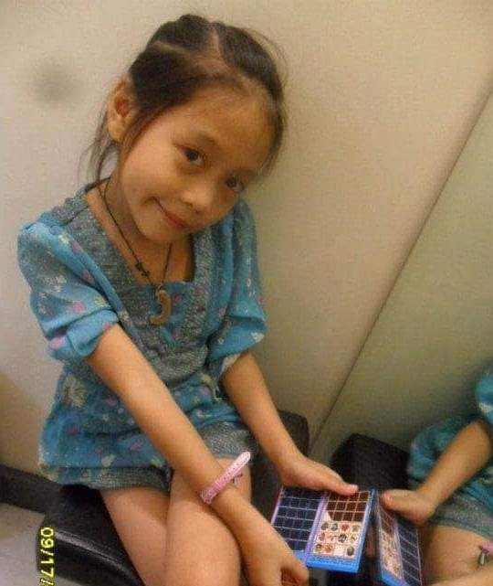 | As a child, I tend to ask for wet paper whenever I sleep. I rub it with my face it until I’m sleepy. Many people often called me a ‘bulilit’ child since I’m very small when I was a child.

- My High School Self
 | Since I start aging up a little, I was a meticulous person. I also grew a talent on art makeup that I sometimes made an income with it.

- My College Self
 | A present me, who try to be the very best person she could ever be.
Technological University of the Philippines
COLLEGE OF LIBERAL ARTS
SOCIAL SCIENCE DEPARTMENT

BETMT-AET-1A-M
UNDERSTANDING THE SELF
ACTIVITY # 5

Answer the following questions cogently but honestly. Write your answers in the space provided.

- How would you describe yourself?
- I would describe myself as a lucky go person who knows her limits. I am ambitious and determined with things I want to do. I do everything for things to go in my way.

- What are the influences of family in your development as an individual?
- One of influence that really stays on my find is that I shouldn’t allow men to define my worth and determine my status on life.

- Think of a time when you felt you were your “true self”. What made you think you were truly who
you are during this time of your life?
- I found my true self is whenever I’m with my girlfriend. She made me feel who I really am when I’m with her. It feels she love me for who I am even I’m flawed and everything.

- Following the question above, can you provide a time when you felt you were not living your “true self”? Why did you have to live a life like that? What did you do about it?
- When I’m with my immediate family. Since I’m not out to my own closet, I have to keep hiding until I’ve proven and provided enough for my family. I had to work beyond my best so I can finally be my true self.

- What social pressures help shape yourself? Would you have wanted it otherwise?
- Probably to be successful. We often say as if it was that easy. However, it helps me to really pursue it. Otherwise, it won’t shape me who I am today and become a burden to me and to society as well.

- What aspects of your self do you think may be changed or you would like to change?
- My passion. Since I grew older, I felt my passion kept changing and doesn’t feel the same as it was. I’d like to change and improve my perspective on life so I can forward.

